CMPS 405 Project Phase 1

Section B03

| Group Members | |
| --- | --- |
| Student ID | Student Name |
| Fahrel Hidayat | 202206836 |
| Josh Erun Bryce Calma | 202203604 |
| Marcus Monteiro | 202206892 |
| Mohd Bashar | 202205153 |

| Task Distribution & Contribution | | |
| --- | --- | --- |
| Student Name | Tasks Assigned | Contribution % |
| Fahrel Hidayat | VM1 Task 3.2, All VM3 Tasks | 25 |
| Josh Calma | VM1 Task 3.1 and 4 | 25 |
| Marcus Monteiro | VM1 Tasks 1 and 2 | 25 |
| Mohd Bashar | VM1 Task 5, All VM2 Tasks | 25 |

**Screenshots:**

**VM1**

Task 1.1

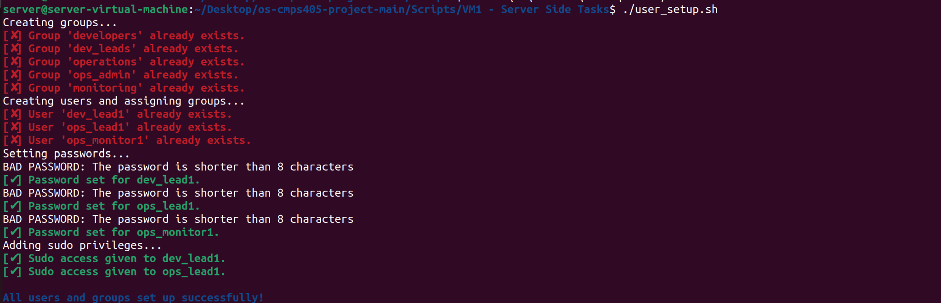

Task 1.2

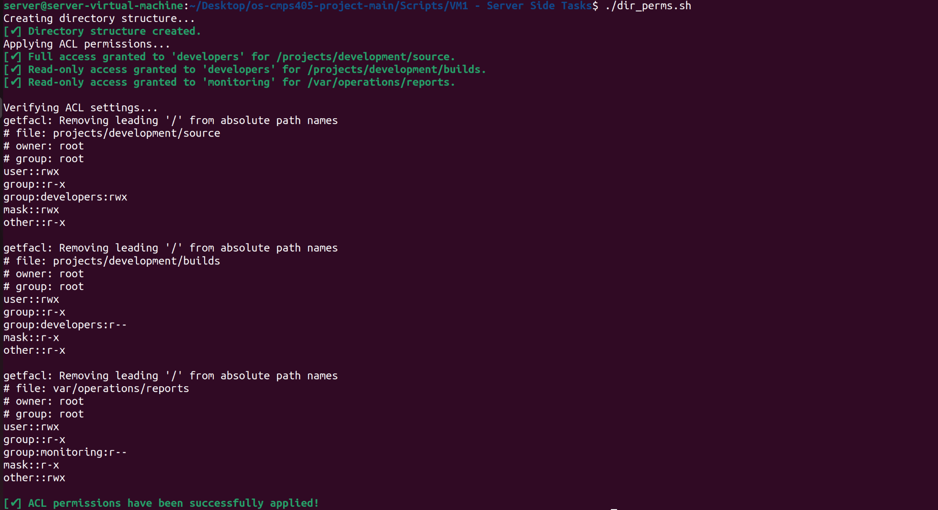

Task 2

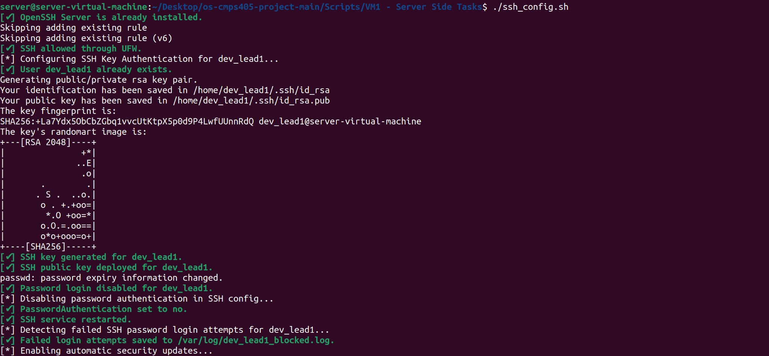

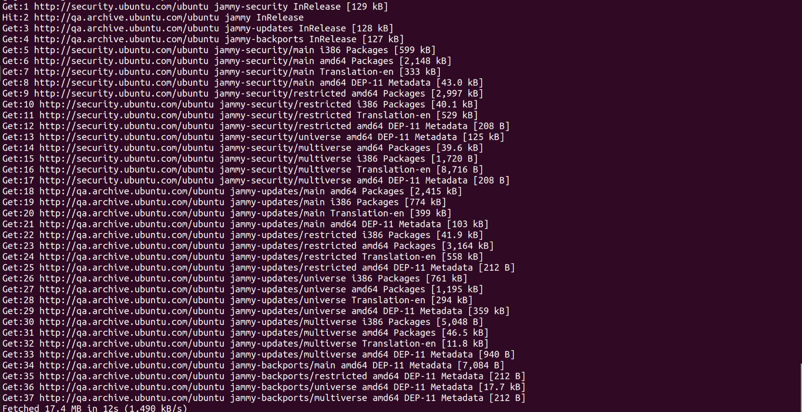

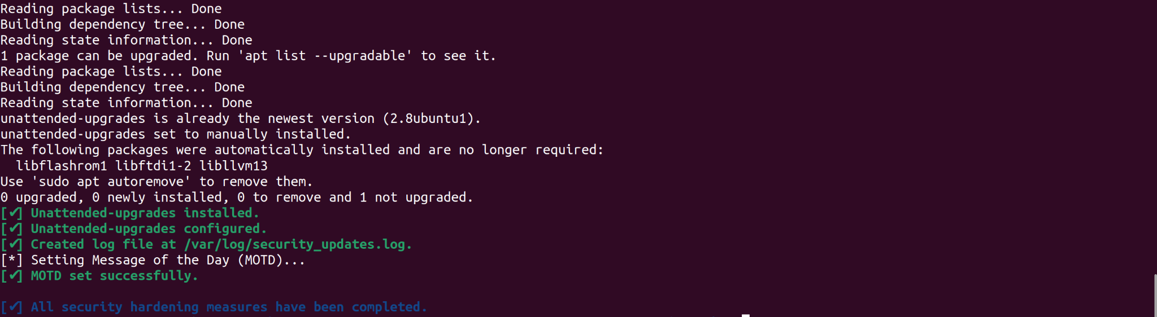

Task 3.1



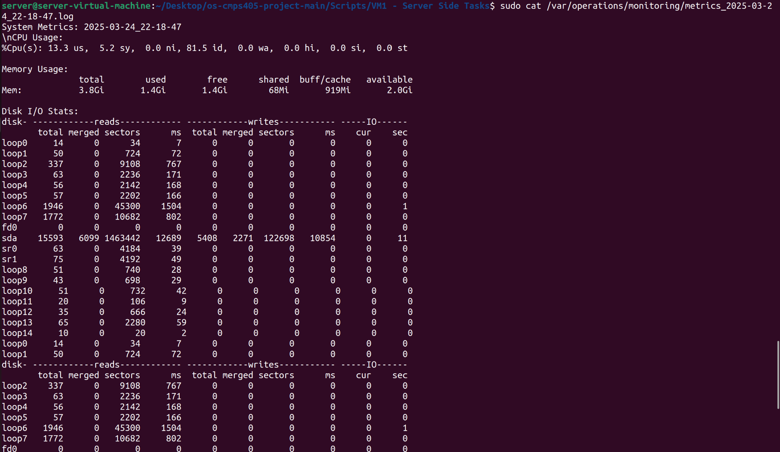

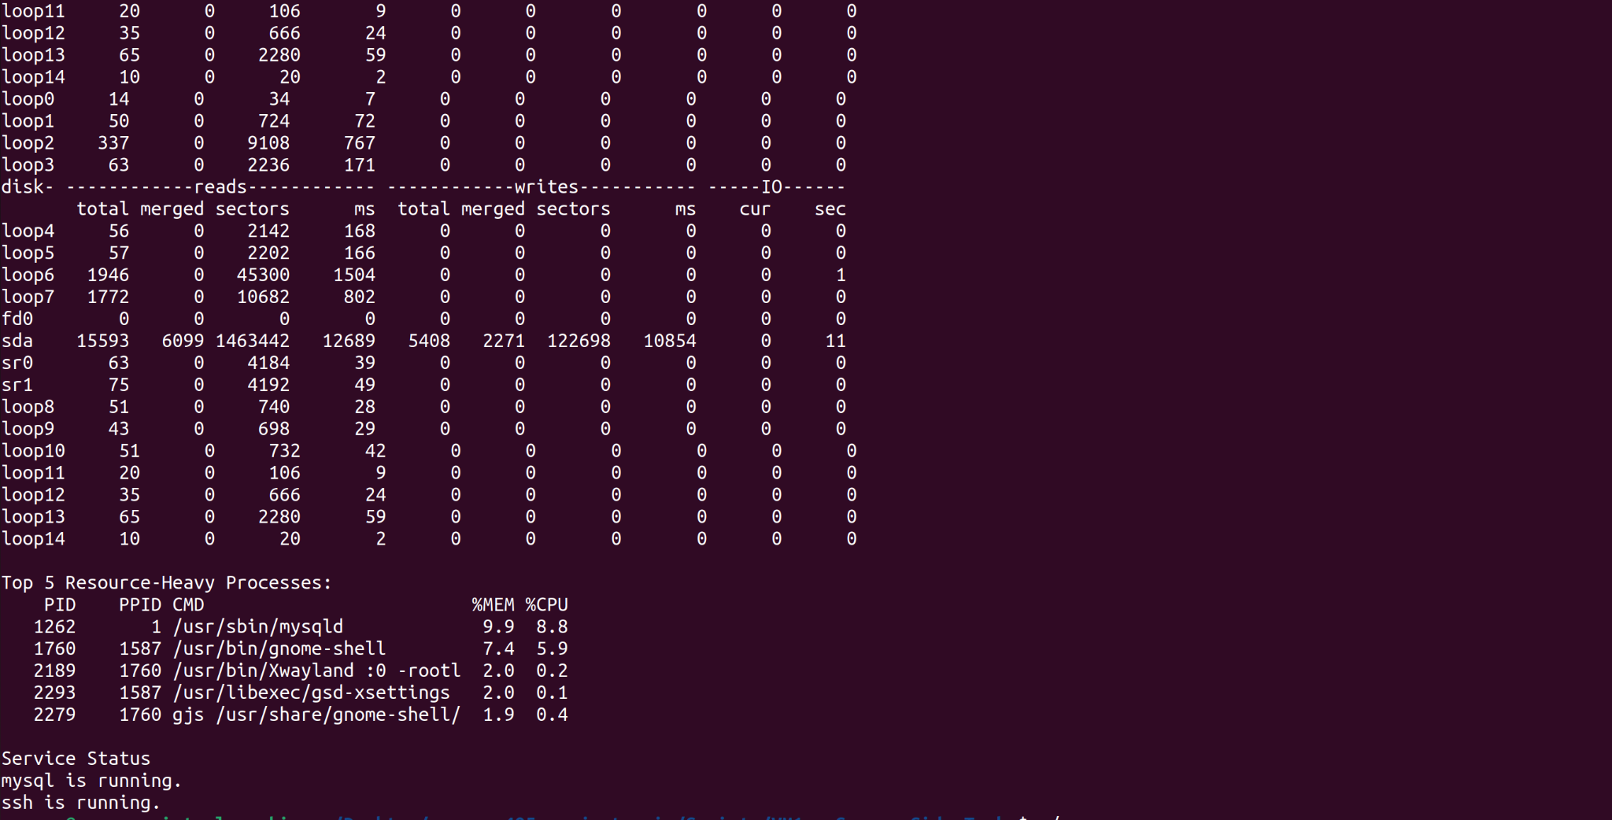

Task 3.2

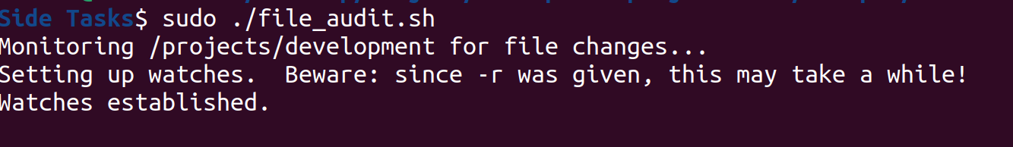

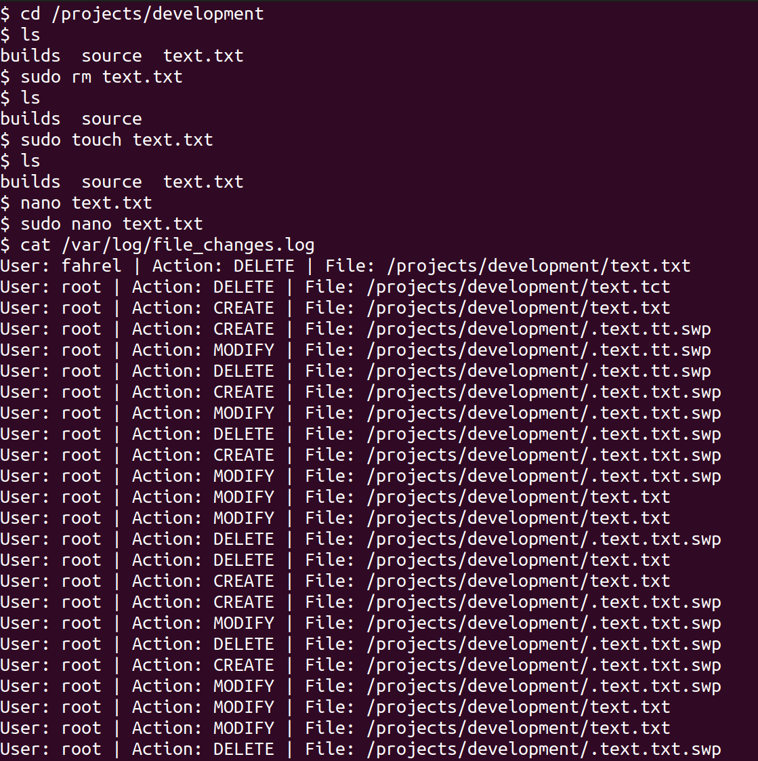

Task 4

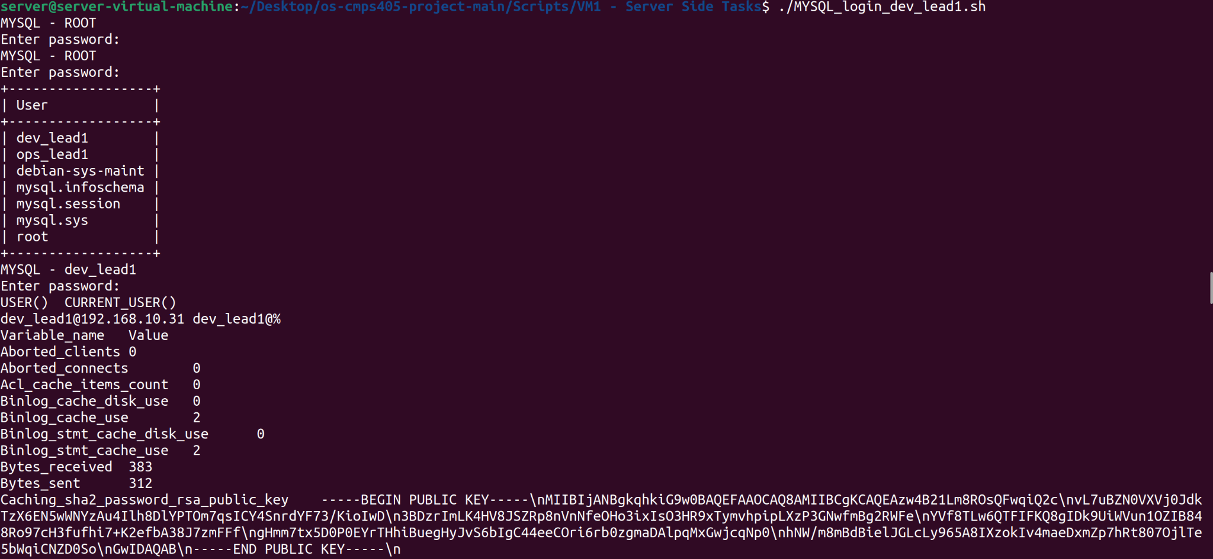

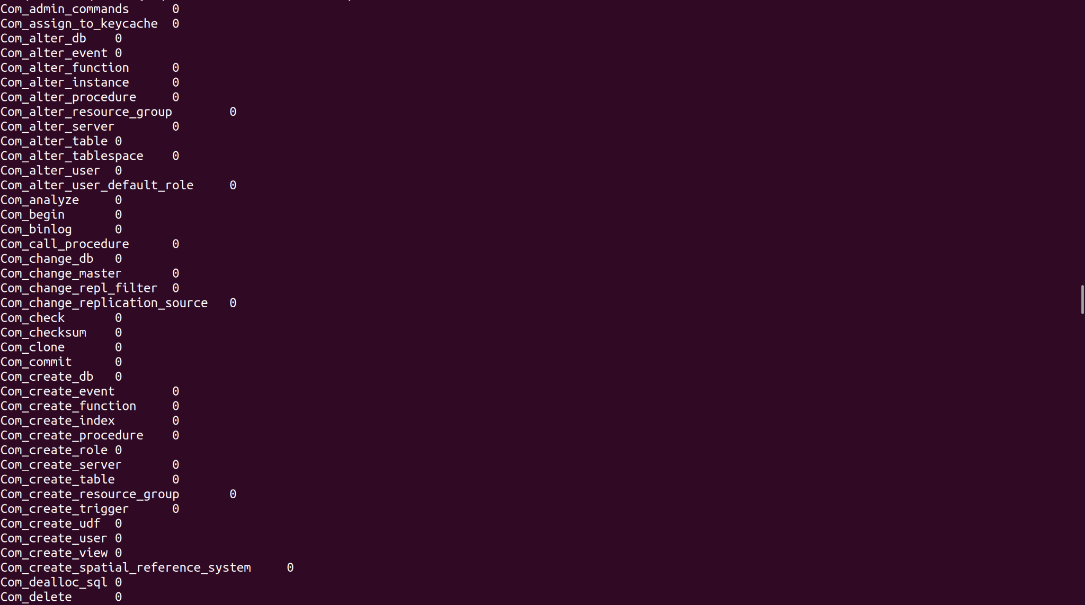



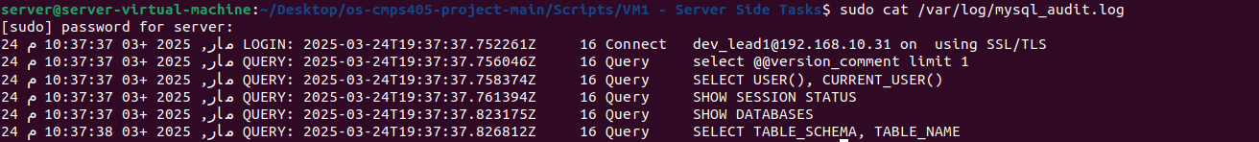

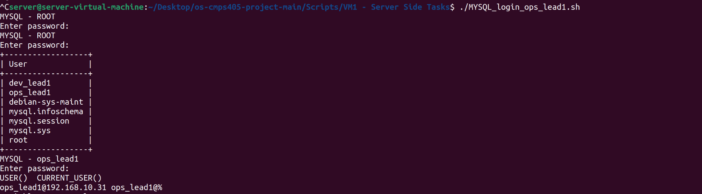



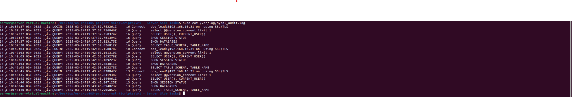

Task 5

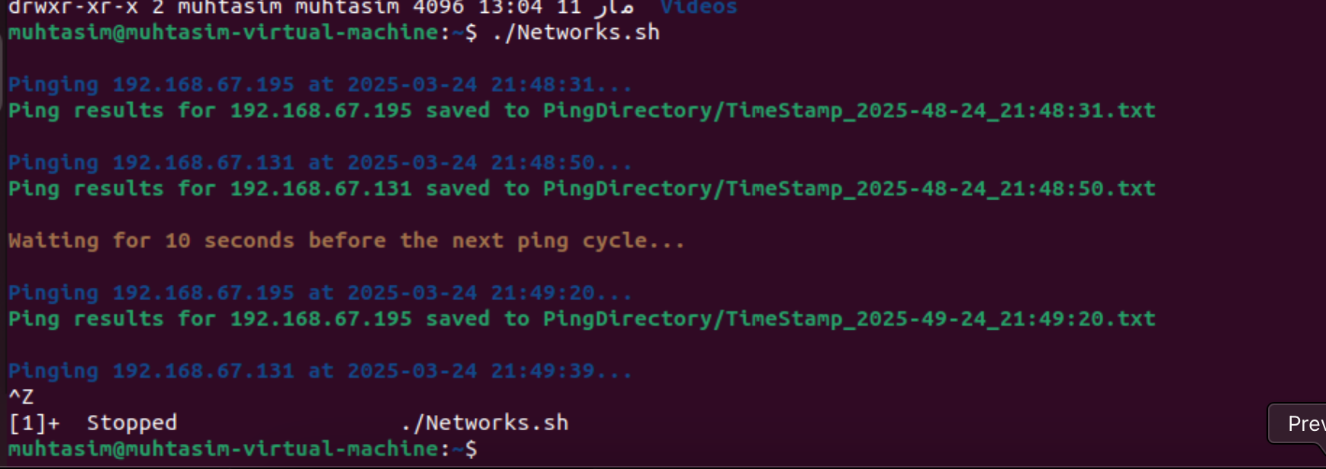

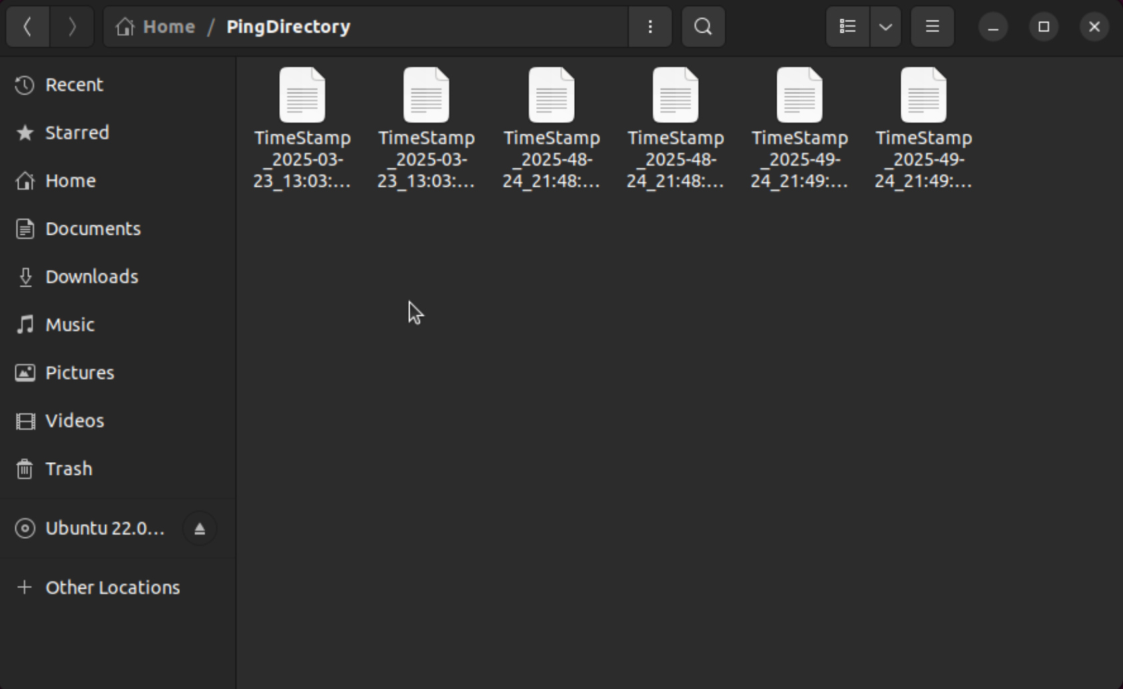

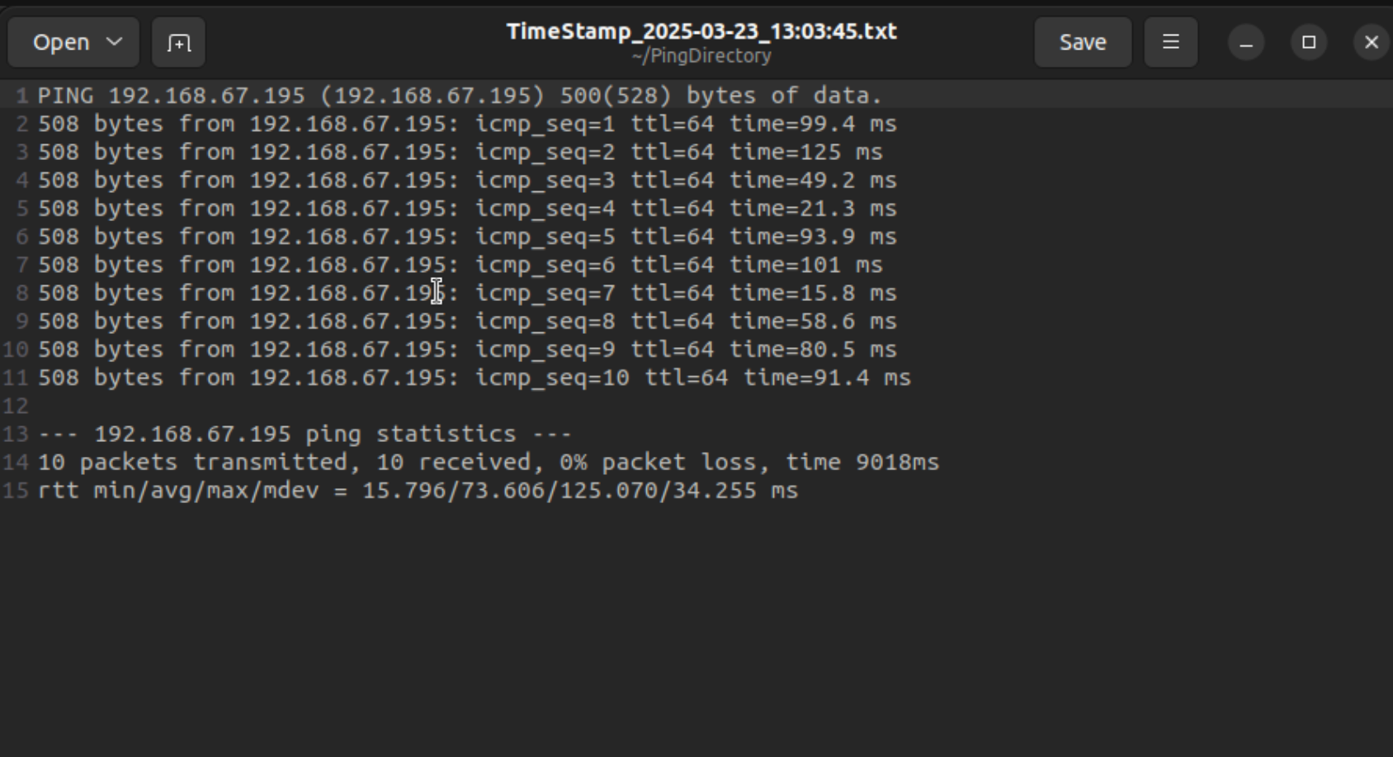

**VM2**

Task 1.2

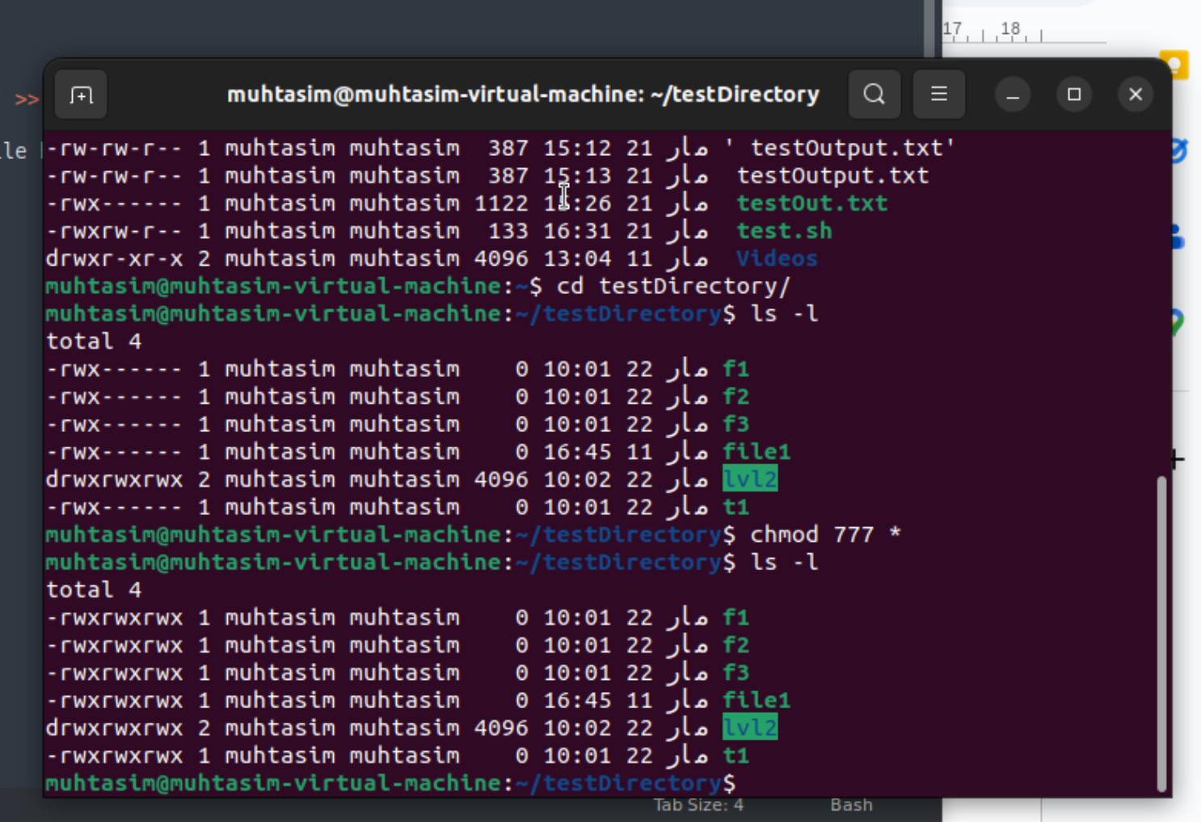

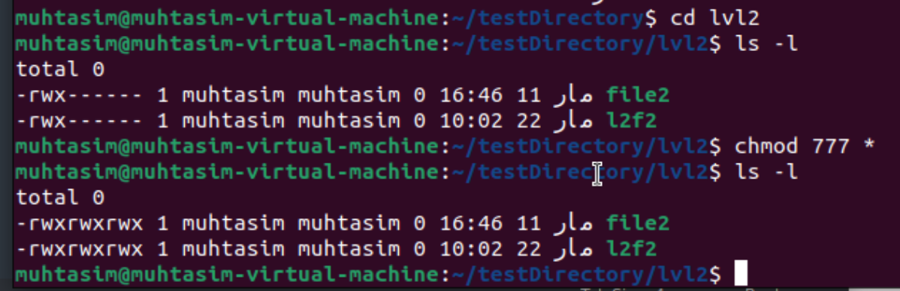

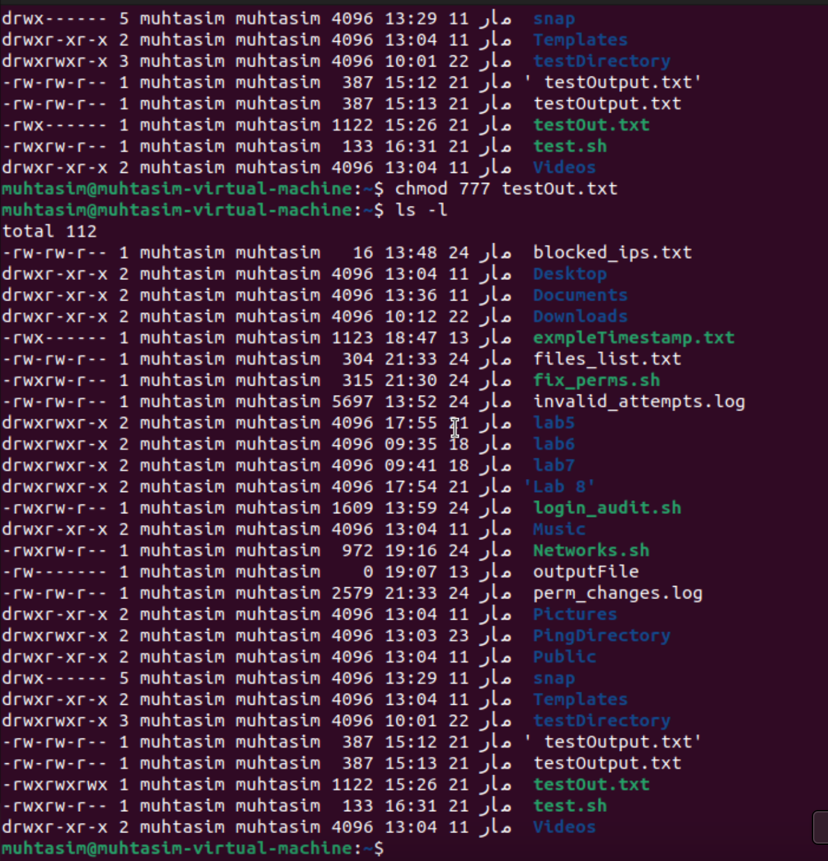

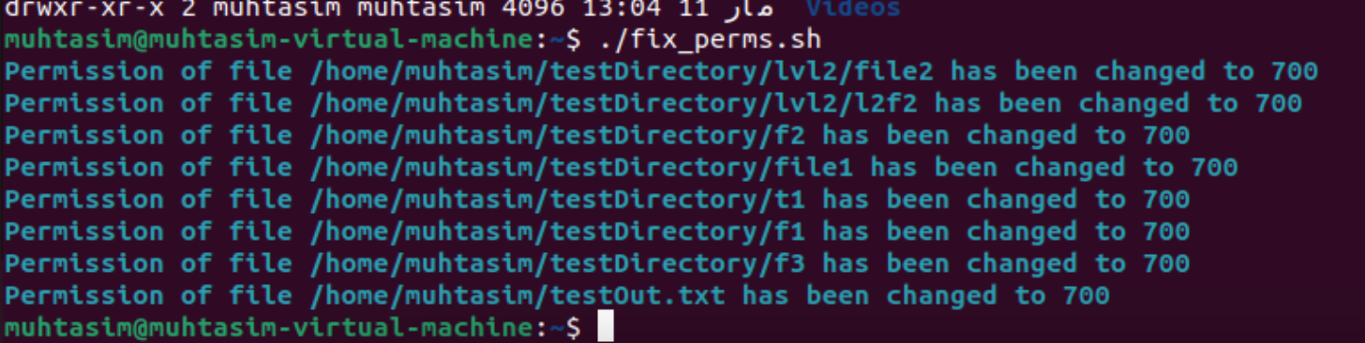

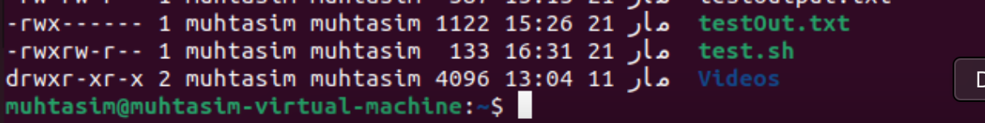

**VM3**

Task 1

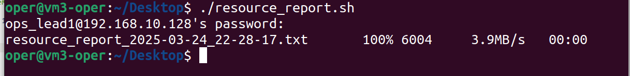

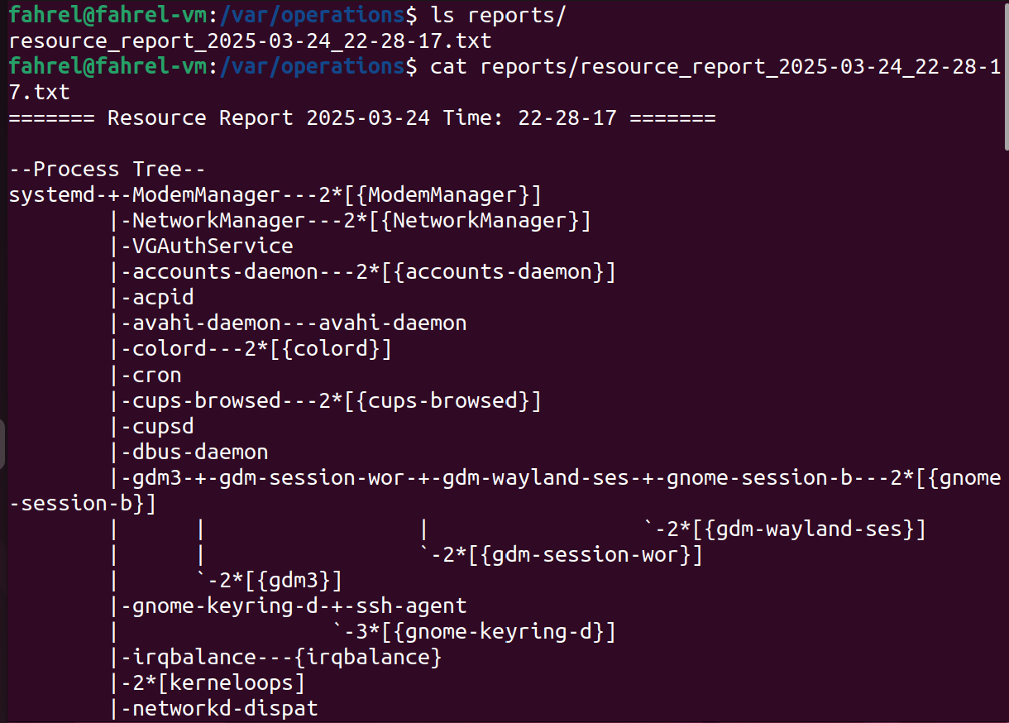

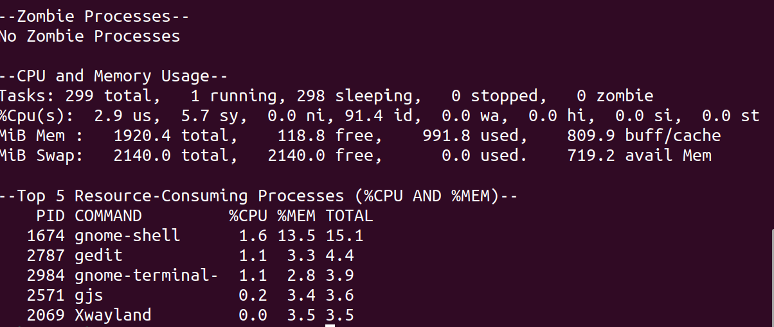

Task 2



